LET’S READ TOGETHER
Learn basic sounds and words
in the English Language.
AN
WORDS
C. 2011 MYGRANDMATIME
Written by Shirley Whitney
Illustrated by Jessica Wheeler
#2
This is the second book in
Grandma’s “A” DVD series
and assumes you know words from
Grandma’s AT book.

WWW.MYGRANDMATIME.COM

Each of the A’s
in this sentence
makes a different sound:
The letter A is
awesome
and
amazing!
When you learn the sentence
you will know the different
sounds that the letter A makes
in the English language.
In the first section of this book
the letter A makes
the same sound
as it does in the word “and”.

CAN
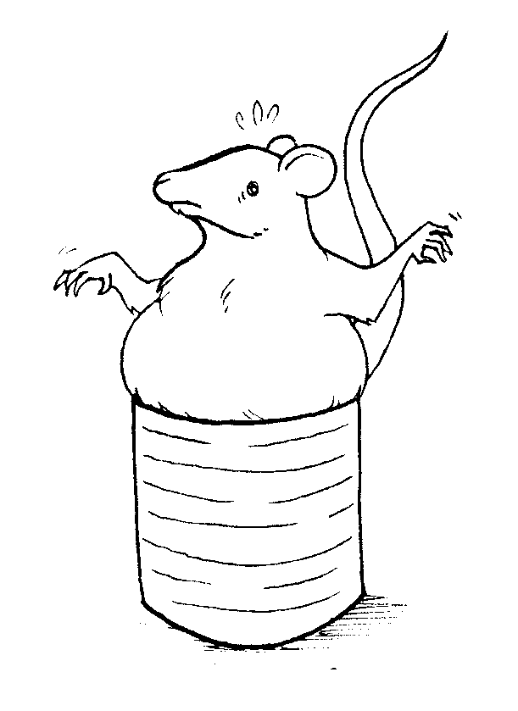
The fat rat is in the can.

FAN
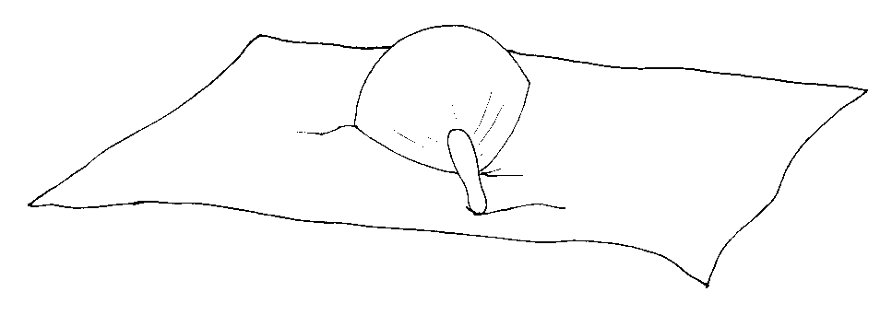
The fan is on the mat.

MAN
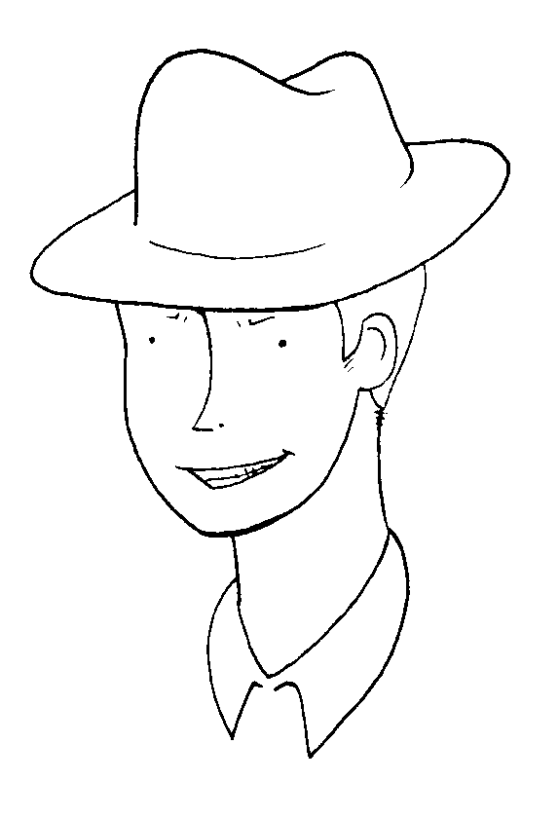
The hat is on the man.

RAN
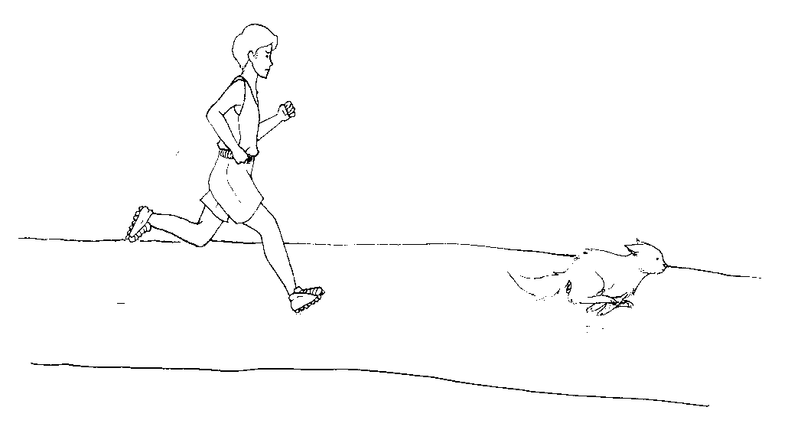
The man ran at the cat.

WARNING!
The A in this word sounds like
the A in awesome!
WAN
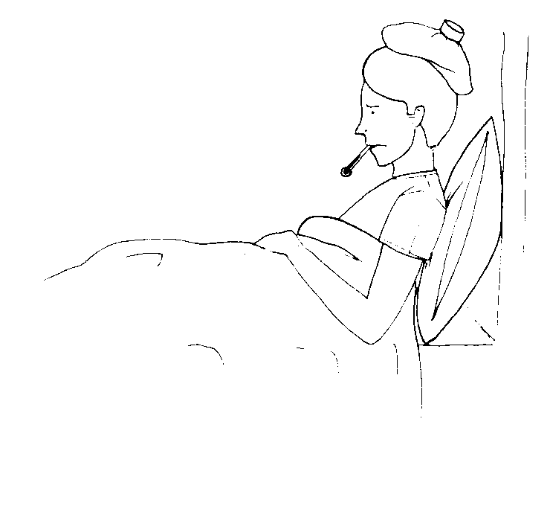
The man is wan.

TAN
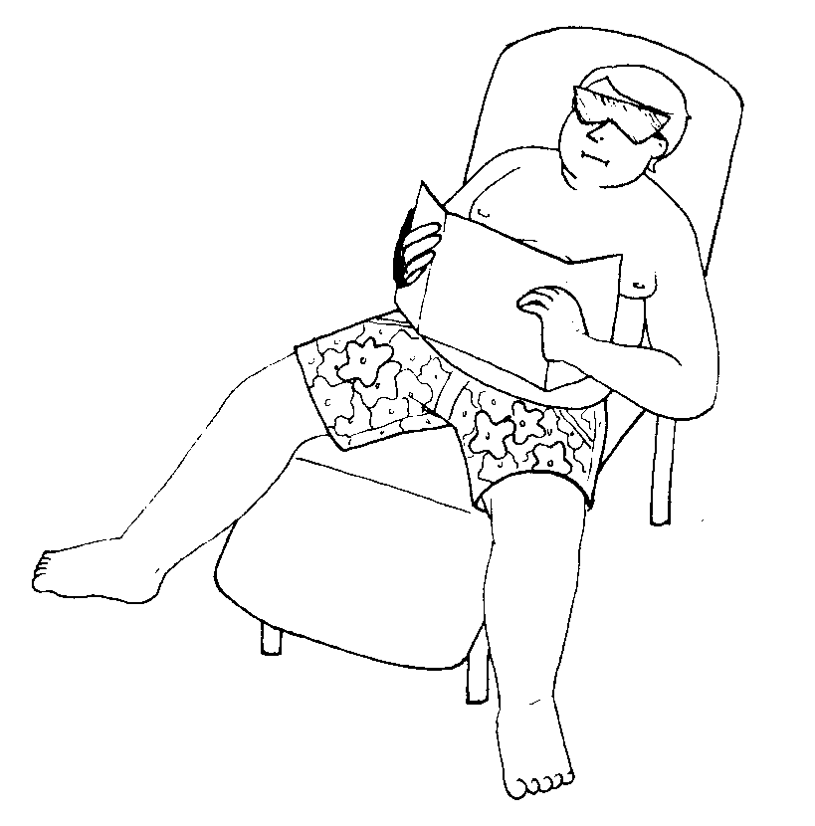
The fat man can tan.

VAN
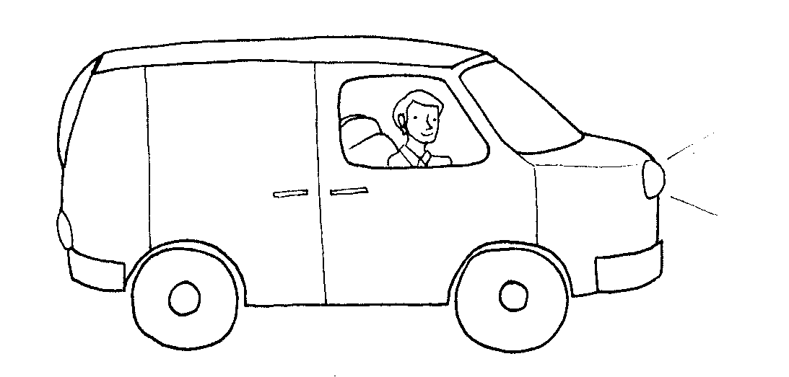
The man sat in the van.

PAN
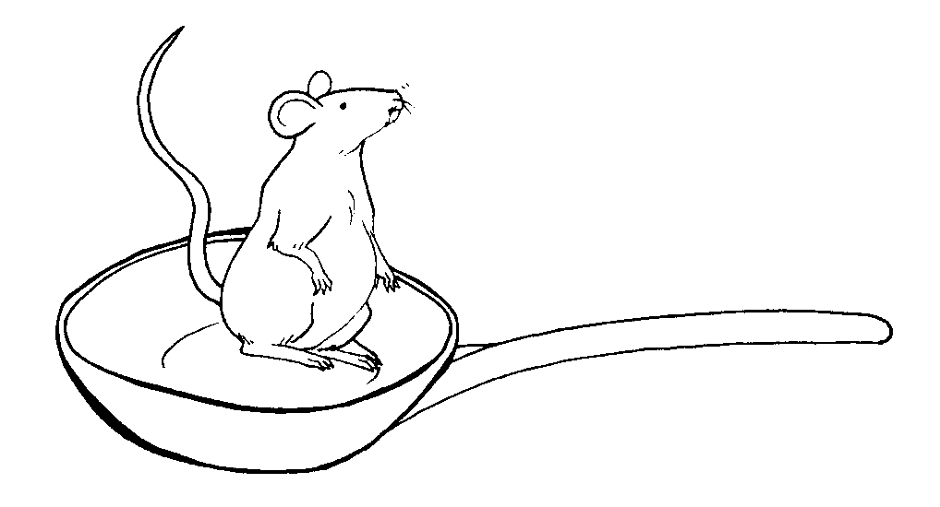
The fat rat sat in the pan.

BAN
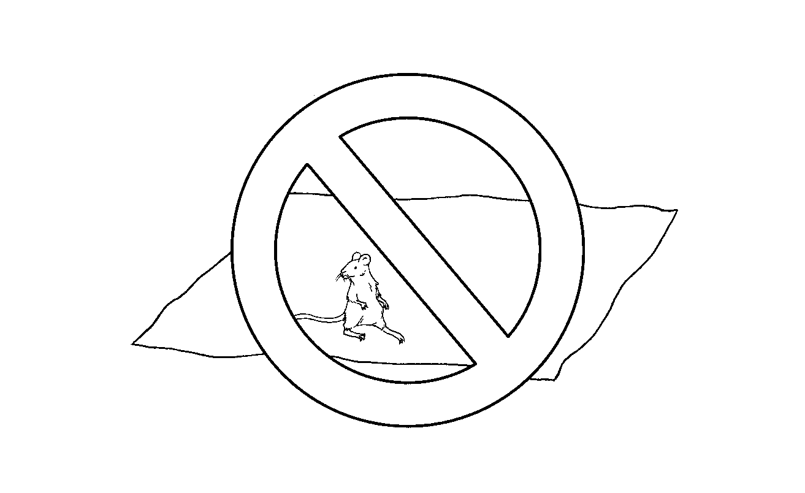
Ban the fat rat
that sat on the mat.
LAN
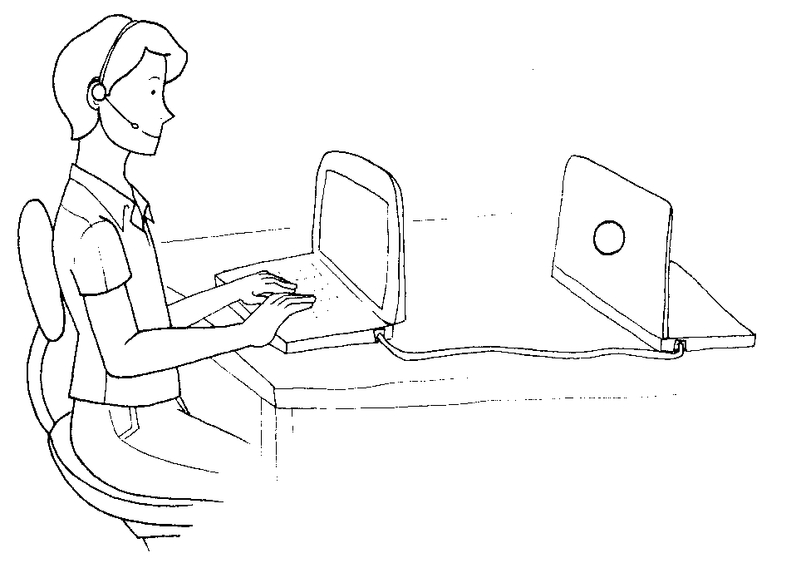
The man is on the LAN.

When you add an E after AN,
the A sounds like its name
and the E is quiet.

Here are some
ANE
words for you to read.

But, don’t forget the
AN and AT words
that you have learned.
You’ll need to use them too!

CANE
The hat is on the cane.

LANE

The man sat in the lane.

MANE

Pat the cat on the mane.

SANE

The man in the hat is sane.

VANE
The bat is on the vane.
PANE

The bat is in the pane.
PLANE

The man sat in the plane.

CRANE
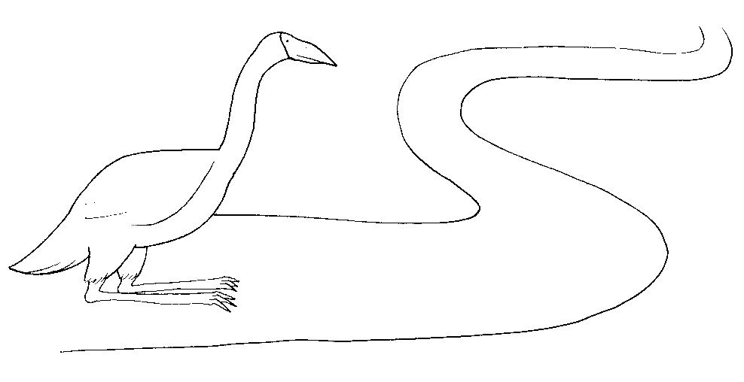
The crane sat in the lane.
When you add an E before AN,
the A is quiet and the
E sounds like its name.

Here are some
EAN
words for you to read.

But, don’t forget
the other words
that you have learned.
You’ll need to use them too!
he man ate the bean.

LEAN

The fat cat ate the lean meat.

MEAN

The mean rat sat on the hat.
EAN

That man is the dean.
CLEAN
The man can clean the pane.
GLEAN
The fat rat can glean.
When you add an O before AN,
the A is quiet and the
O sounds like its name.

Here are some
OAN
words for you to read.

But, don’t forget
the other words
that you have learned.
You’ll need to use them too!

MOAN

Pat the fat cat that can moan.

LOAN
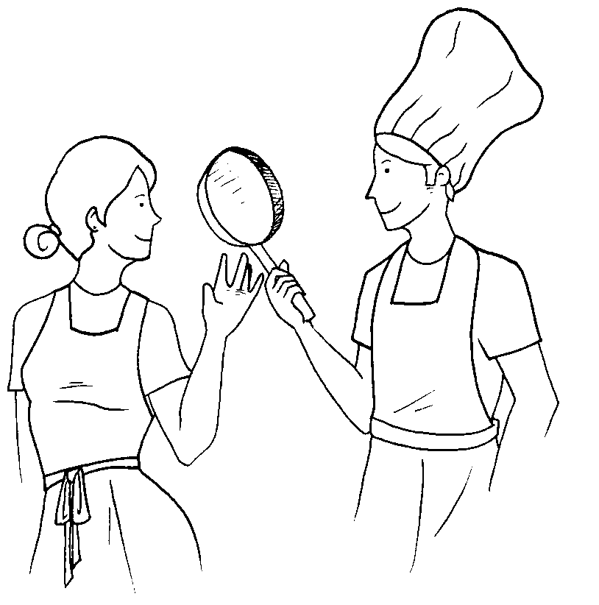
The man can loan the pan.

